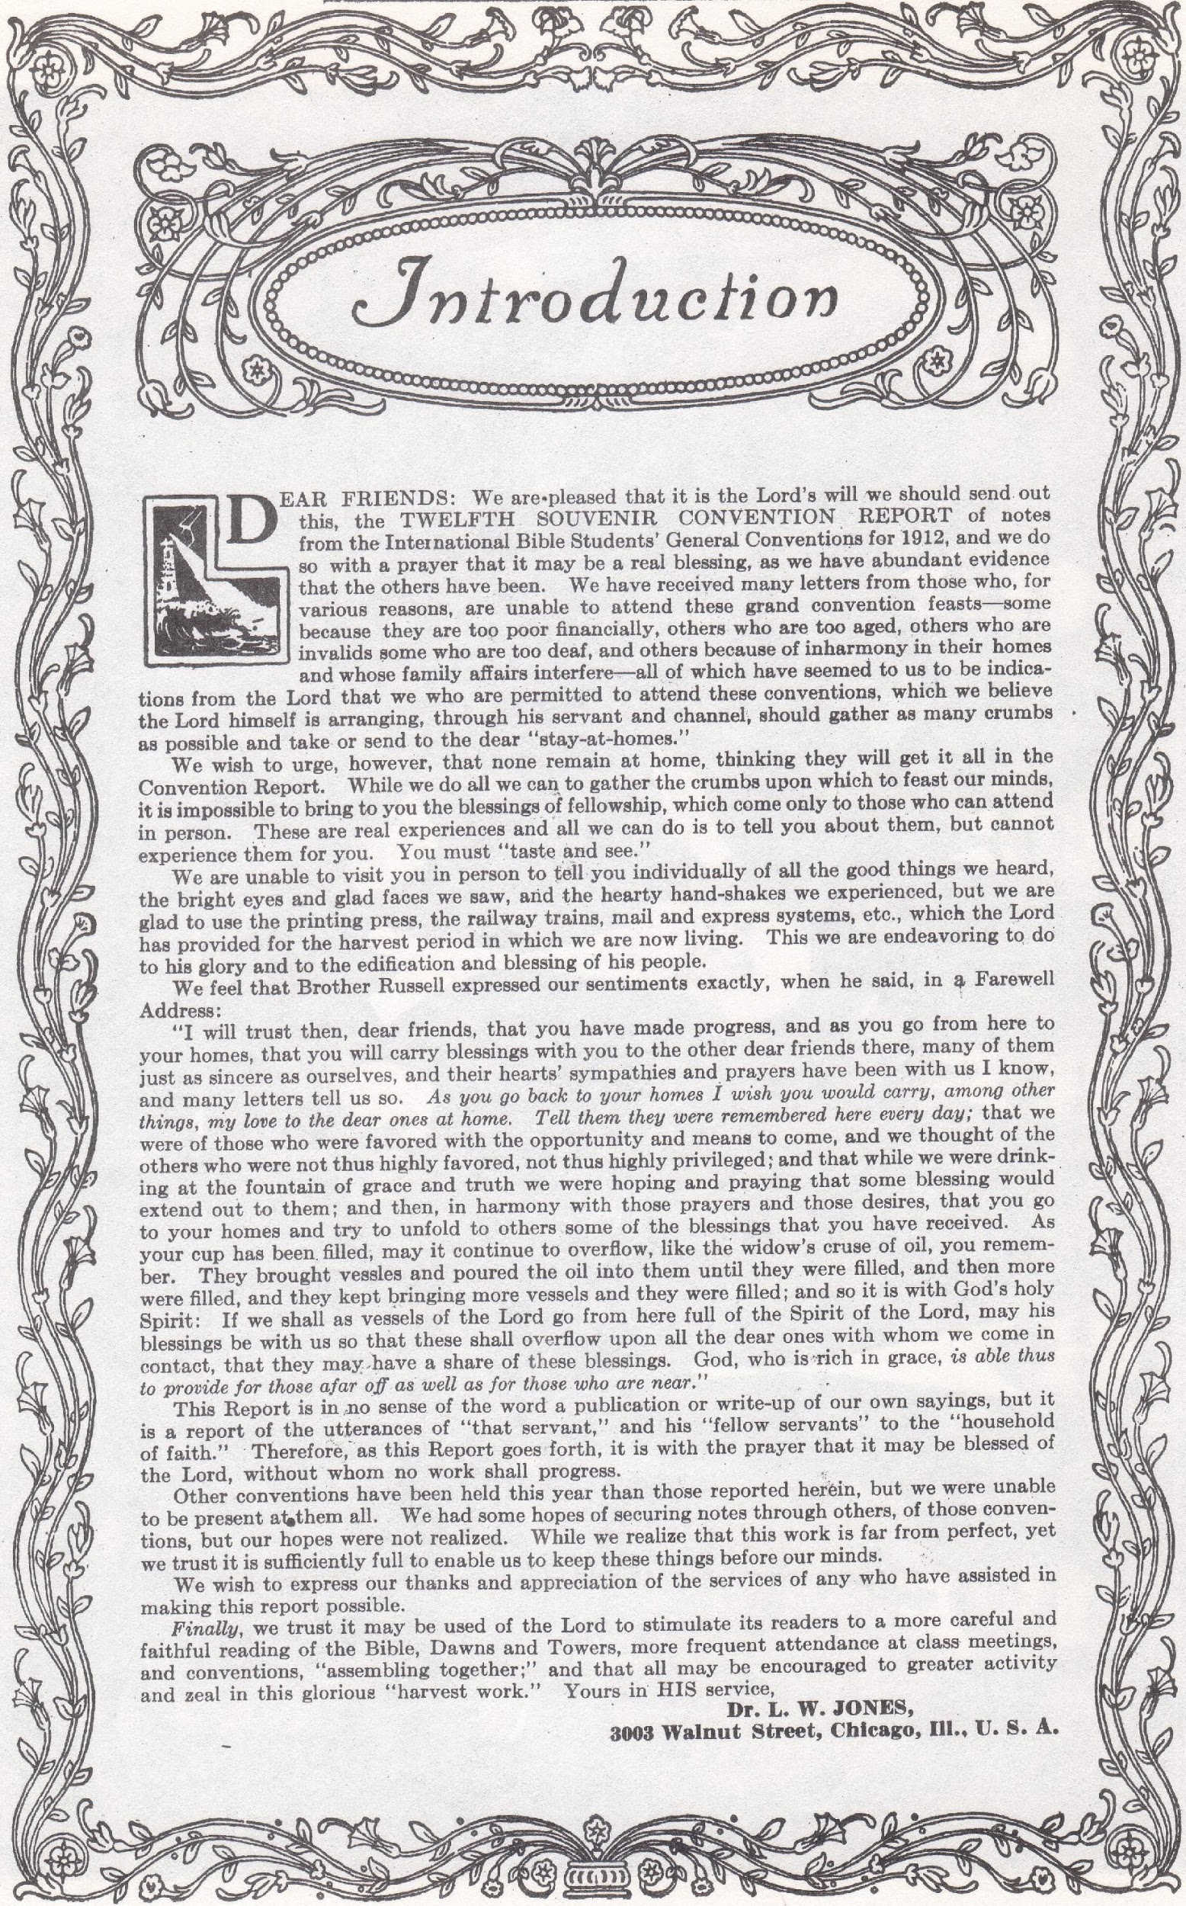
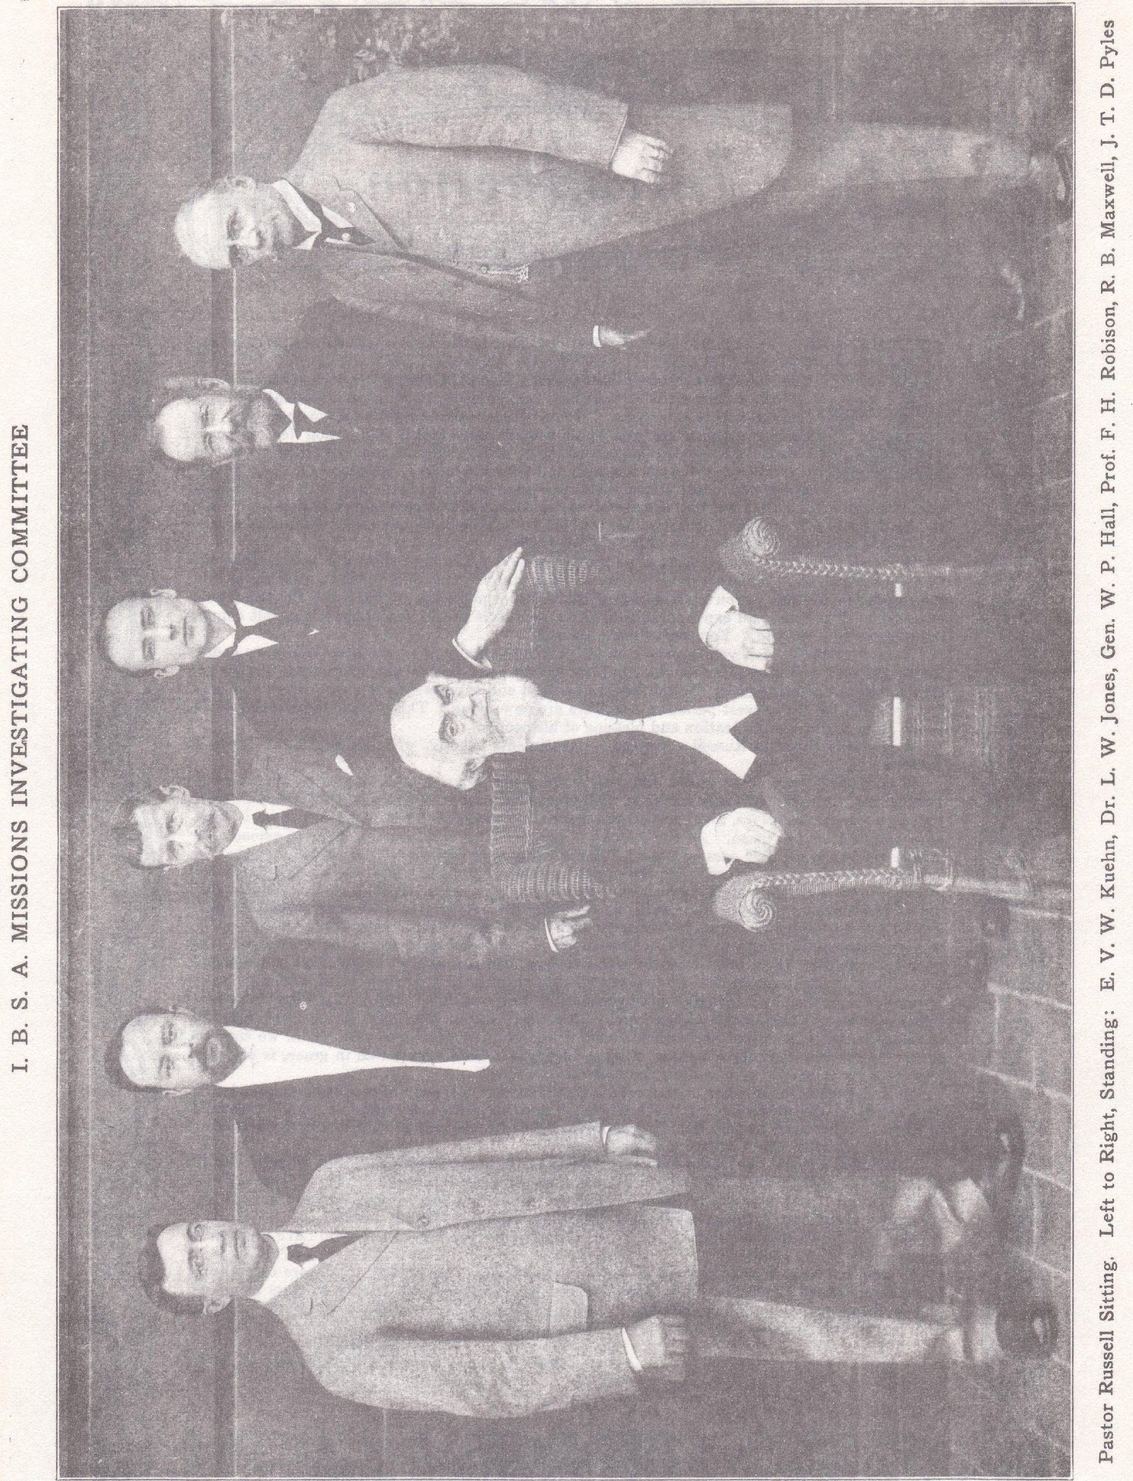
(The sermon below given by Pastor Russell on board S. S. Shinyo Maru, Sunday Dec. 24, 1911, by request of Captain Smith. This was the start of the trip by the committee appointed to investigate missionary activities in the Orient. Start of sermon on page 14 of the 1912 Convention Report.)

Our text is chosen from the chapter read, Romans 1:16: “For I am not ashamed of the gospel of Christ; for it is the power of God unto salvation to everyone that believeth; to the Jew first, and also to the Greek.”

There are many religions and it is a mistake that we have, perhaps, said in the past that there is no religion but one. A religion would properly be considered: “Any system of worship by which any people recognize the Almighty and seek to do Him honor.” We are therefore, to recognize the various great religions that are in the world, in the sense that we would not properly ignore them. We have, for instance, the Confucian teaching, the Brahmin teaching, the Buddhist teaching, the Mohammedan teaching, the Jewish teaching and the Christian teaching. These all present themselves to us as religious teachings. They all believe themselves more or less rational; they all believe themselves more or less reasonable. Every man tries to think that his own theory on any matter is a reasonable theory, and he is proper in so doing.

This morning, in harmony with our text, we propose to compare the religion of Jesus to all other religions. In the beginning, we state with the Apostle, “I am not ashamed of the gospel of Christ.” Whatever may be said of other gospels, we believe, as Christians, that in the Christian religion we have that of which no man need be ashamed. There may, perhaps, be certain features and forms of certain creeds of which we might be ashamed—they do not come up to our highest ideals. But the Christian religion, as presented in the Word of God, should be the standard of Christianity, and of that we are not ashamed. It will compare with all other religions in the world, and come off victorious in every sense of the word. All of these various religions seem to recognize that man is in an imperfect, unsatisfactory, sinful condition; therefore, each of these religions seek to present certain tenets, or teachings, that will help him up out of his imperfect condition, back into harmony with his God.

If we consider the teachings of the Mohammedans, they have certain qualities which are very advantageous, and other qualities that we could not so highly recommend. Their endeavor is not to do injury, but to make man better. Their theory is that mankind are fallen and need lifting up out of their fallen condition. The same may be said of the Brahmin, the Confucian and the Buddhist. They are all more or less presentations of what are supposed to be cures for man’s fallen condition, cures for his unsatisfactory attitude. Some of these religions offer one kind of a penalty for those who will not accept them, and others offer other kinds. Some offer one kind of reward for those who accept and follow their teachings, while other offer other kinds of rewards. But all agree that man needs to be elevated and lifted up out of his fallen condition, which is sinful and unsatisfactory. There seems to be in every man naturally, without any education on the subject, something which tells him that he is not perfect, not in full accord with his own conscience, not in accord with his own highest ideals of the divine mind. All religions, therefore, recognize this principle of sin and propose remedies therefor. We see the evidence of these as manifested in their disciples everywhere. Some seek to crucify the flesh in one form or another—some by flagellations, some by restraints upon the various liberties of life, some by holding their hands in the air for days, seeking to become holy and thus appease their god. None of these things seem, to our minds, in the light of the gospel of Christ, to be the highest and noblest ideals. Doubtless all have done some good and uplifted some men out of the degradation in which they were. Mankind might have been worse off if it had not been for these religions.

But now, if we compare these with the religion of Jesus Christ, we believe everything is to be said in favor of the religion of Christ. In the first place, all of these religions more or less resemble the Jewish religion, which is of God, and hence all of these religions are all more or less in harmony with God’s proposition. His proposition to the Jews was, “Do these things and ye shall live,” have everlasting life. That was the Covenant made by God with them at Mount Sinai at the hands of Moses. They thought at first that they would surely be lifted up out of sin, because God had given them a law, and by keeping it they would be perfect and be brought into harmony with God. In this they were mistaken, because, as they found out, that as the centuries passed, none of them were able to keep the law, because it is the measure of the perfect man’s ability, and none of them could measure up to the perfect man. The Jews found, as the Apostle states it, “By the deeds of the Law shall no flesh be justified in His sight.” But they found, also, that the Law, instead of perfecting, justifying them and giving them eternal life, the Law brought to them a greater realization of sin than they ever had before, and this was the real blessing of the Law Covenant—it showed them their sinful condition and their inability to lift themselves out of it. The Jews do not recognize that great fact today, for if they did, they would be crying to God for mercy instead of trying to keep the Law and thus justify themselves.

But the same thing might be said to be true of all the heathen religions. All offer help by which mankind may make themselves perfect, but none are able to make themselves perfect, and they all realize that they are sinners and imperfect to the last degree. There is, therefore, nothing that is logical in any of these, because they all start out to claim that a man ought to be perfect, ought to be holy, and are agreed that he is not. This agrees with the words of God with respect to Israel. “By the deeds of the law shall no flesh be justified in His sight.” It agrees with all of these that man is a sinner, that he cannot do the things that he would, that his ideals are to be and are higher than his capacity and ability. And so St. Paul declares, “We cannot do the things which we would.”

Christianity answers that the reason is that we are fallen creatures, sold under sin. Who sold us, when and where? The Bible answers that, “By one man’s disobedience sin entered into the world and death by sin, and so death passed upon all men.” Death has passed upon the entire race and thus impoverished it mentally, morally and physically, so that now, because of the fall, we cannot do the things which we would like to do.

The Bible tells us that originally Adam was not in our condition, but was perfect and he could do and could keep the divine law perfectly, but that we are sold under sin. And so the Prophet David expresses that same thought, “I was born in sin, shapen in iniquity, and in sin did my mother conceive me.” So we behold, my dear friends, that we are a race of sinners, imperfect mentally, morally and physically; and therefore, unable to keep the divine standard or law. What, then, does Christianity offer us that no other religion offers us? Christianity offers us a Saviour, and no other religion offers a Saviour. Christianity recognizes that the condition came about by one man’s disobedience, Adam, and it sets forth Jesus as the One who redeems man from that death sentence that came upon our first parents, “As by a man came death, by man came also the resurrection of the dead,” writes St. Paul. “For as in Adam all die, even so all in Christ shall be made alive,” writes St. Paul—“Every man in his own order.” Here, then, Christianity has a superiority logically, in that it provides for a satisfaction of divine justice. All religions say that it is divine justice that is opposed to sin, but Christianity offers a satisfaction for divine justice. “Christ died for our sins,” “Gave Himself a ransom for all.” “He is a propitiation [satisfaction] for our sins [writes the Apostle] and not for ours only, but also for the sins of the whole world.” So, then, Christianity is not only more logical, but is more just—it recognizes Divine justice. We must recognize that if God condemned the world understandingly and truly, as the Great Judge of mankind, there must be some satisfaction of justice ere the Chief Justice of the universe could set aside the penalty and release the culprit. Man has sinned and the great Chief Justice has passed the sentence, and there is no way to revoke that sentence, except by meeting it. And so, Christianity sets forth that our Lord Jesus came into the world to meet the penalty, and that He by the grace of God tasted death for every man.

Christianity has another superiority over all other religions, and it is this: That it recognizes a love and compassion upon the part of God that no other religion recognizes. All these religions do recognize a God, and I claim it makes very little difference whether they call him Allah or Jehovah or some other name; they recognize, we believe, the same one God, but they do not recognize His real traits of character. They perceive His justice, and their own transgressions of Divine justice, but they do not see the merciful provision that God has made. Their god is represented by the Chinese idol, which pictures the character of God. I remember a Chinese banner I once saw—the figure on this banner represented a very demon-like character, and lightning was represented as flashing from his closed fist. He was a god to be feared, one who would take vengeance upon them.

The God of the Bible, while just, is not a vengeful God, not unkind; but, on the contrary, He is the God of all grace, the Father of mercies, from Whom cometh every good and perfect gift. And the great gift that He gave is the greatest of all gifts, the gift of His Son for man’s sin, that thus He might offer a satisfaction to His own Justice. Nor was this at the expense or contrary to the will of the Redeemer; because the Scriptures make clear that it was by virtue of the prize set before our Lord, as we read, “For the joy that was set before Him He endured the cross despising that shame.”

This love of God is not content with merely the provision of the Saviour, and the arrangement that if anybody shall hear and believe he shall be blessed, but this love of God proposes to go still further namely: That he who thus redeems the race shall become the King of earth, and his scepter or rule shall be from sea to sea and from the river to the ends of the earth, until every knee shall bow and every tongue confess to the glory of God, and the knowledge of the Lord shall fill the whole earth as the waters cover the great deep, and every creature shall come to know that there is a God, and that the way He proposes to be just and merciful is through His Son, Who is to be the great Deliverer of the race.

In what way will this great Deliverer come? This is a part of the gospel, a part of the good tidings—it is through His great Kingdom which He will set up in His own due time. His Kingdom shall not be merely for the rich, or powerful, but for the poor. He shall lift up the poor from the dunghill, is a part of the prophecy. His power and influence shall be the great lifting principle that will level the whole world of mankind. As the Scriptures declare, all men are on a common level before God, for all have sinned and come short of the glory of God and all are recipients of Divine mercy. The blessing of the Lord is that all may come back, and when thus brought back to all that was lost in Adam and redeemed by Christ, they will be able to keep the Divine law perfectly and will, therefore, to all eternity be in covenant relation with God. Those who refuse to enjoy that blessing prepared for them, the Scriptures clearly declare that God has not prepared a place of torment for them, but has provided a second death—“The soul that sinneth it shall die.” “The wages of sin is death.”

So, then, my dear friends, the gospel of Christ is worldwide. But, you say, What about the Church? You have been speaking about the world and what Jesus will do for it. What about the Church? Oh, my dear friends, those of us who have experienced the power of this salvation know that as a power it has not lifted us physically to perfection, but has a power that has come into our hearts, into our minds, through faith, by transforming, by converting us, our minds, our wills. I recognize some in our midst whom I know were once aliens, strangers and foreigners to the Lord, who by a knowledge of the Saviour have become transformed in their lives so that now they are seeking to walk not after the flesh, but after the Spirit, the Spirit or mind of God, after the Divine will so far as possible according to the Divine law. Here we see the difference between the Jew under his covenant of law and the Christian under the higher covenant that the Lord has made at the present time. The Apostle said that the Jew could not do the things that he would, but he declares equally strongly that the righteousness of the Law is fulfilled in us who walk not after the flesh but after the Spirit. How, then, is this possible? Are we better than the Jews? Are we of less fallen nature than the Jews, and made perfect? Nay, verily. The Apostle explains that for the class now called out during this Gospel Age there is a special arrangement in operation, and God deals with these according to their minds, their wills, their intentions, so that under this Covenant of Grace, which we are enjoying, we are counted as fully keeping the Divine Law, the righteousness, the full meaning of the Law is fulfilled in us who are walking not after the flesh, but after the Spirit. Not up to the Spirit, but after the Spirit. But how could we be fully justified if not able to walk up to the Spirit? The answer is, that the blood cleanses us and commutes our sins, and he imputes his perfection and righteousness to us so that our best endeavors are accepted in Jehovah’s sight as perfect, for we are justified, not according to the flesh, but according to the Spirit.

Another way in which the Gospel of Christ is superior to all others is that this gospel is world-wide. No other gospel of which I have knowledge is world-wide. The Gospel of the Son of God is that “Jesus Christ by the grace of God tasted death for every man,” rich and poor, Jew and Gentile, every nation and people and kindred and tongue. “There is a wideness in God’s mercy like the wideness of the sea.” I know of no other religion that is so unbiased, that recognizes no national lines, that has the thought that we are one race, which sprang from one man, condemned through one man, and redeemed through the man Christ Jesus, and that all are to have a blessing—no other religion under the sun.

The religion of Christ, of which we are not ashamed, is best in this that it is the most God-like religion, because of its breadth, because of its justice, because of its impartiality, because of its love, its goodness and merciful qualities; it shows forth as does no other religion the Justice, Wisdom, Love and Power of Jehovah, our God. To Him be glory and honor and dominion forever.

